Vs code study

1. Console.log(“this is a text”);

Eta holo print kora

1. Const data= “this is a text”;

Console.log(data);

==print

1. const data_one= "this is a text";

const data_two= "hello";

console.log(data_one+data_two);

1. // const data_one= "100";
2. // const data_two= "hello";
3. // const data_three= 56
4. // const data_four= "ostad"
5. const arrayData= ["100","hello",56,"ostad"]
6. console.log(arrayData [3]);

5. function first(){

    const arrayData= ["100","hello",56,"ostad"]

console.log(arrayData [3]+arrayData [1]);

}

first();

ei first lekha mane holo func ke call kora otherwise kisui show korebena

6. function first(){

    const arrayData= ["100","hello",56,"ostad"]

console.log(arrayData [3]+arrayData [1]);

}

first();

debug korsi. Ekta breakpoint (laal) click kore, then.

7. function first(){

    //const arrayData= ["100","hello",56,"ostad"]

const a= 6;

const b= 10;

console.log(a+b);

}

first();

ans is 16

9. egula holo paramaeter pass kora. Automation e onk kora hbe.

function first(a){

    //const arrayData= ["100","hello",56,"ostad"]

//const a= 6;

//const b= 10;

console.log(a);

}

first("Hello learners");

10. last e first lekhi coz multiple func thakle pare. Like func first, func second. Kon func bujanor jonno

Ektai func but diff data disi sob print korse

11.10 15 25 dsi. But a. b so 25 nibei na. this is called FUNCTION OVERLOAD

12.

1. jodi return result r por

console.log (sum(4,2)) lekhi ota print hobe return mane end er porer line r porbena

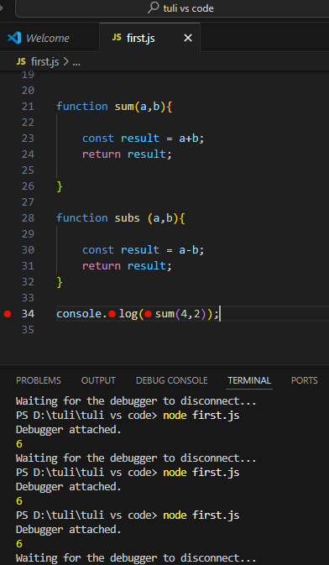

1. sum er por return deya lagse jate ei addiotn er value ami bar bar use korte pari.

1. ami last er sub er return na likhe ami jodi chai vitore console dye print korte pari tahle baire console likte hbena. But baire subs(4,2) likhbo

1. multiply and division practice

1. second.js

function second(){

const data = ["data_one", "data_two", 3, ["arr_one",2], "End"];

console.log(data[0]);

}

second();

result is data one

1. **understanding loop**

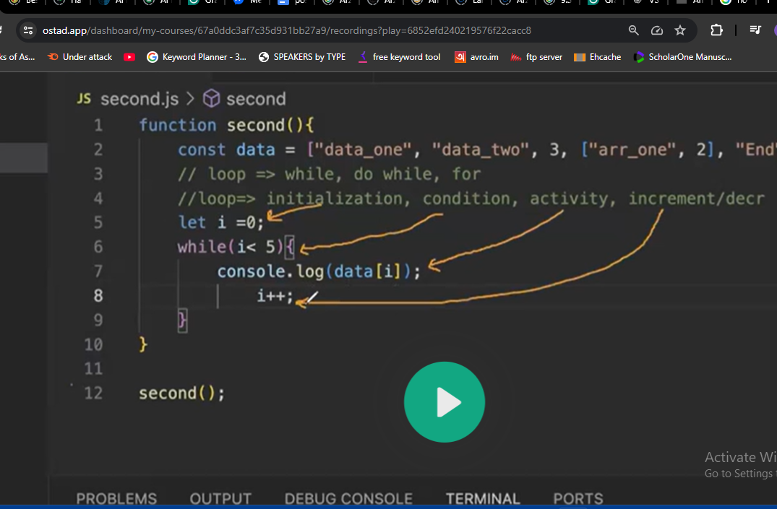

function second(){

    const data = ["data_one", "data_two", 3, ["arr_one",2], "End"];

        //console.log(data[0]);

        let i=0;

        while(i< 5){

            console.log(data[i]);

            i++;

        }

}

second();

result: Debugger attached.

data_one

data_two

3

[ 'arr_one', 2 ]

End

1. ami jodi const dei. Tar mane etat value change hobe na. but i++ thakay eror dekhacche.

function second(){

const data = ["data_one", "data_two", 3, ["arr_one",2], "End"];

//console.log(data[0]);

const i=0;

while(i< 5){

//console.log(data[i]);

i++;

}

}

second();

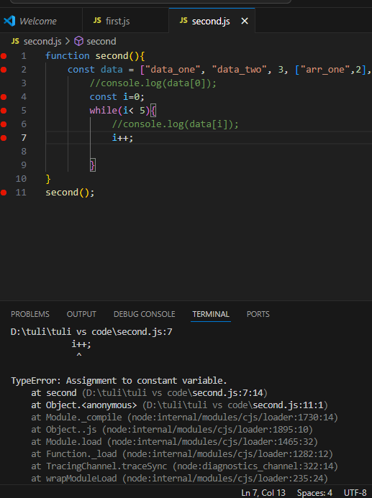

1. const er data while loop er vitorer rakhle se eta baire use korte parbena

function second(){

const data = ["data_one", "data_two", 3, ["arr_one",2], "End"];

//console.log(data[0]);

let i=0;

while(i<1){

//console.log(data[i]);

i++;

const test= "hello";

}

console.log(test)

}

second();

1. const k ami while scope er baire rakhle while er vitoreo print korte parbe. Baireo parbe,

function second(){

const data = ["data_one", "data_two", 3, ["arr_one",2], "End"];

//console.log(data[0]);

const test="hello";

let i=0;

while(i<1){

//console.log(data[i]);

i++;

//const test= "hello";

console.log(test);

}

console.log(test)

}

second();

1. let test=hello, etao while scope er modde use korle otar vitorei print kora dekhabe. While loop er baire print hobena.

Tar mane const test=hello eke to change kora jabena, while e use korle only okhanei print hobe. Baire use korle baire print hobe.

Let test=hello ei value change kora jabe. While scope er vitor use korle only okhanei print hobe baire na.

function second(){

const data = ["data_one", "data_two", 3, ["arr_one",2], "End"];

//console.log(data[0]);

let i=0;

while(i<1){

//console.log(data[i]);

i++;

//const test= "hello";

let test= "hello";

console.log(test);

}

console.log(test)

}

second();

1. const and let er je limitation ase seta mitbe jodi ami var dei.

Var test= hello

function second(){

const data = ["data_one", "data_two", 3, ["arr_one",2], "End"];

//console.log(data[0]);

var i=0;

while(i<1){

//console.log(data[i]);

i++;

//const test= "hello";

var test= "hello";

console.log(test);

}

console.log(test)

}

second();

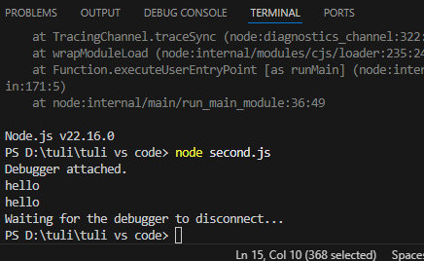

1. ekhane data.length likhlei hobe

function second(){

const data = ["data_one", "data_two", 3, ["arr_one",2], "End"];

//console.log(data[0]);

let i=0;

while(i<data.length){

console.log(data[i]);

i++;

}

}

second();

result==5ta data ee dekhabe

1. ekhon for loop

function second(){

const data = ["data_one", "data_two", 3, ["arr_one",2], "End"];

//console.log(data[0]);

for(let i =0; i< data.length; i++){

console.log(data[i]);

}

}

second();

1. 2 dimneiosnal array kmne dekhe.

function second(){

const data = ["data_one", "data_two", 3, ["arr_one",2], "End"];

//console.log(data[0]);

console.log(data[3][1]);

// for(let i =0; i< data.length; i++){

//console.log(data[i]);

//}

}

second();

result====2

1. Third.js file ekhane number k 2 dye vag kore vagsesh 0 ashve eta dekbo

function checkOddEven(number){

if(number%2==0){

console.log(number + “ is an even number”);

}

else{

console.log(number + “ is an odd number”);

}

}

checkOddEven(4);

1. or you can write with backlash==============

If else

function checkOddEven(number){

if(number%2==0){

console.log(`${number} is an even number`);

}

else{

console.log(`${number} is an even number`)

}

}

checkOddEven(4);

result=4 is an even number

1. njk

function checkOddEven(number){

if(number%2 ==0 && number>0){

console.log(`${number} is an even number`);

}

else if(number%2 ==1 && number){

console.log(`${number} is an odd number`)

}

else{

console.log(`${number} is not valid in this case`)

}

}

checkOddEven(0.5);

result=============

0.5===not valid

4===odd

5===even

Arek vabe lekha jay====

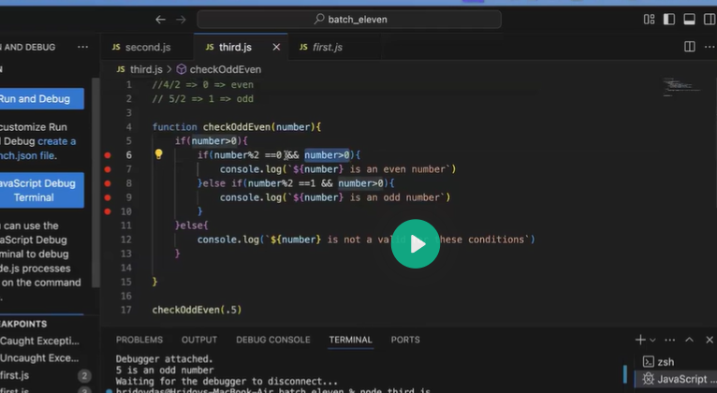

Constructor and class:

Class.js

class Eleven {

sum(a,b){

const result = a+b;

return result;

}

subs(a, b){

const sumResult = a+b;

const result= sumResult-3;

console.log(result);

}

}

module.exports = new Eleven();

etake baire export kore use korbo. So I create classTwo,js file.

classTwo,js

const Eleven = require("./class");

class ClassTwo{

test() {

Eleven.sum;

}

}

Ami jodi arekta class add korte chai.

class Eleven {

sum(a,b){

const result = a+b;

return result;

}

subs(a, b){

const sumResult = a+b;

const result= sumResult-3;

console.log(result);

}

}

class Twelve{

subs(a, b){

const sumResult = a+b;

const result= sumResult-3;

console.log(result);

}

}

module.exports = new Eleven();

module.exports = new Twelve();

in classTwo.js file….we write

//const Eleven = require("./class");

const Twelve = require("./class");

class ClassTwo{

test() {

Twelve.hello;

}

}

Class e kono parameter pass kora Jayna….class suru hoy second bracket diye. Function e pass kora jay. Ota third bracket diye.

But onek somoy class keo parameter pass korte hoy. Sei concept k **constructor** bole

Er porer code er explanation

myCar holo Eleven class er ekta **OBJECT or replica.**  So myCar Eleven er vitor sob kicu access korte pare.

In class.js file======we write

class Eleven{

constructor(carName, model){

this.name = carName;

this.model = model;

}

}

const myCar = new Eleven("honda", "CRV");

console.log(myCar.model);

result---myCar.name===hinda

myCar.model===crv

jodi function lekhi se data pass korte pare. So constructor lekhina

function car(carName, model) {

this.name = carName;

this.model = model;

}

const myCar = new car("honda", "CRV");

console.log(myCar.model);

result==========crv